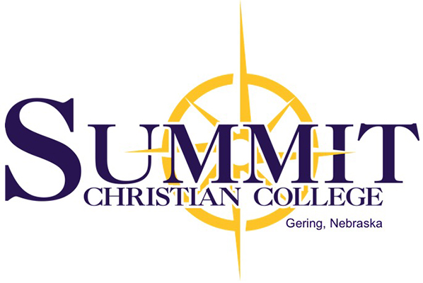

Summit Christian College
2025 21st Street
Gering, Ne 69341
Ph: 308-632-6933
*President’s Scholarship application due July 15

*Submit completed application to the Recruitment Department during the application process.

Student Name
MIDDLE
FIRST
LAST

Street Address/PO Box_____________________________ City _____________________ State____ Zip _________

Home Phone Cell Phone

Marital Status __________________________________________________________________________________

Degree ________________________________________________________________________________________

Qualifications:
**President’s Scholarship is a one-year tuition scholarship for new incoming freshmen during the academic year
following high school graduation based upon high school academic achievement.

Must be a full-time degree-seeking freshman.

Final transcript must be submitted upon high school graduation. Final GPA will affect scholarship.

25% tuition for an ACT score of 23 and an accumulative GPA of 3.0
50% tuition for an ACT score of 25 and an accumulative GPA of 3.5
100% tuition for an ACT score of 27 and an accumulative GPA of 3.75

Please list your ACT Score ______________ and cumulative GPA ________________

I certify upon my honor that the answers submitted in this application are true, to the best of my knowledge. If admitted
to Summit Christian College, I agree to abide by both the spirit and the letter of the rules of Summit Christian College, and
to conduct myself at all times in a manner worthy of a servant of the Lord Jesus Christ.

________________________________________________________________________________________________
Signature Date

Summit Christian College admits students of any race, color, and national or ethnic origin to all rights, privileges, programs and activities generally made available to students at the college. It does not discriminate on the basis of gender, race, physical handicap, national or ethnic origin in administration of educational programs, admissions, employment practices, athletics, or other activities. The college actively seeks to fulfill federal, state, and local laws and regulations in all its practices and facilities.

“Summit Christian College, an Institution of Higher Learning, Educates Leaders for Christian Service.”

