Each student attending must submit this completed form.
Cost: $45 Pre-registered $55 at the door

Fall Fling 2019 Registration and Parental Release Form
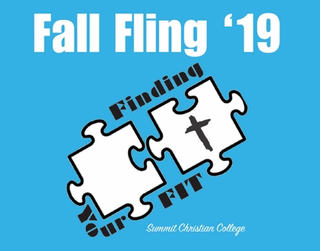
Family Registration

Parent/Guardian Name: _________________________________ Emergency Phone: _____________________

Address: __________________________ City: ______________________ State: ________ Zip: ____________

Student 1 Name: _____________________________________ Gender: _______ Grade: _______
T-shirt Size: S M L XL 2XL 3XL Is your child currently taking prescription medication? ____________

Please list the nature of any medical conditions: ____________________________________________

___________________________________________________________________________________

Allergies? Food: _____________________ Pet: __________________Other: _____________________

Student 2 Name: _____________________________________ Gender: _______ Grade: _______
T-shirt Size: S M L XL 2XL 3XL Is your child currently taking prescription medication? ____________

Please list the nature of any medical conditions: ____________________________________________

___________________________________________________________________________________
Allergies? Food: _____________________ Pet: __________________Other: _____________________
I give permission for the above listed student(s) to attend Fall Fling in Gering, NE, on November 8-10, 2019. I agree my student will be under the authority and direction of his or her church/adult sponsor and/or their Summit Christian College Assigned Leader. I realize that there are inherent risks involved with large groups and physical activities, and I assume all responsibility for my student’s behavior. I will not hold Summit Christian College, Central Church of Christ, or the sponsoring church responsible for any injuries or accidental death to my student while at Fall Fling. In the case of needed emergency medical care, I give permission for treatment to be given to my child(ren) without first notifying me, and I will not hold any medical personnel or medical center responsible for rendering necessary emergency services.

__________________________________________________________________________________________
Parent or Legal Guardian Signature Date
I give permission for photos and videos of my child(ren) to be published in print and/or digital format for Fall Fling and Summit Christian College promotional purposes.

__________________________________________________________________________________________
Parent or Legal Guardian Signature Date

