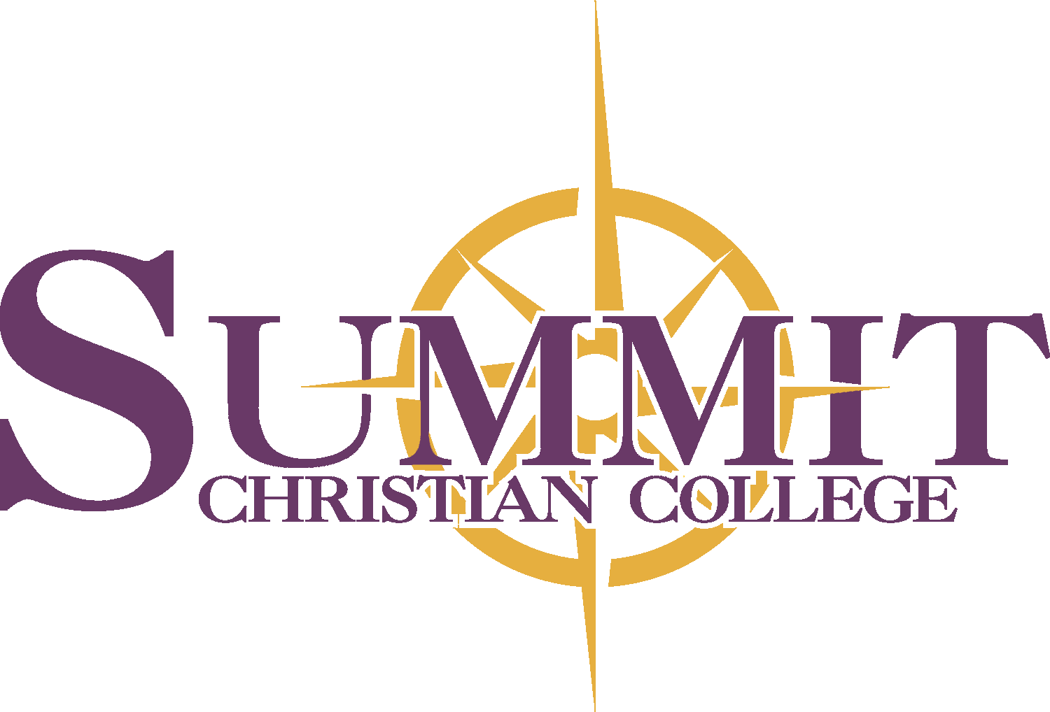
Tabitha scholarship application

Summit Christian College
2025 21st Street
Gering, Ne 69341
Ph: 308-632-6933 Fax: 308-632-8599

Qualifications*
1. Must be a returning, full-time degree seeking female student enrolled in a Bible major
2. Must submit a 500-word essay that includes the following:
a. A description of the career you would like to pursue, and
b. The characteristics that you consider most important in a Christian leader.
3. Must submit completed application and essay to the Financial Aid office.
4. Must not be on Academic or Character Probation
5. Must have fulfilled Mentored Ministry and Chapel requirements

*Dispersed as funds are available

Student Name
FIRST
MIDDLE
LAST

Street Address/PO Box ____________________________ City ___________________ State ___ Zip ___________

Home Phone Cell Phone

Marital Status

Classification for upcoming college year: ⓪ Freshman ⓪ Sophomore ⓪ Junior ⓪ Senior

Major

I certify upon my honor that the answers submitted in this application are true, to the best of my knowledge. If admitted to Summit Christian College, I agree to abide by both the spirit and the letter of the rules of Summit Christian College, and to conduct myself at all times in a manner worthy of a servant of the Lord Jesus Christ.

DATE
SIGNATURE

Summit Christian College admits students of any race, color, and national or ethnic origin to all rights, privileges, programs and activities generally made available to students at the college. It does not discriminate on the basis of gender, race, physical handicap, national or ethnic origin in administration of educational programs, admissions, employment practices, athletics, or other activities. The college actively seeks to fulfill federal, state, and local laws and regulations in all its practices and facilities.

“Summit Christian College, an Institution of Higher Learning, Educates Leaders for Christian Service.”

